

**BASIC COMPUTER PROGRAMMING**

**DEE 4113**

**LAB MODULE 1**

**STUDENT NAME: Ho Weng Yin**

**STUDENT ID: 1125240324610**

**PROGRAMME: Diploma in Electrical Electronics Engineering (ODL)**

**SEMESTER: Year 1 Semester 1**



**FACULTY OF ENGINEERING**

**EXPERIMENT 1 (C3, PLO2):**

**SYNTAX, STRUCTURE AND PROBLEM SOLVING OF C PORGRAMMING**

* 1. **Objectives**

1. To be relate with syntax and structure of C programming.
2. To identify the problem solving techniques using C programming.

**2.0 Equipment List**

Online C Compiler

**3.0 Problem Statement**

**3.1 Problem Statement 1:**

Write a program to calculate and display the volume of a CUBE having its height (h=10cm), width (w=12cm) and depth (8cm).

**3.2 Problem Statement 2:**

Write a program to calculate and display the area of triangle having its base (b=15.2cm) and height (h=30.5cm).

**4.0 Results**

**4.1 Pseudo code**

**Problem Statement 1:**

Write a program to calculate and display the volume of a CUBE having its height (h=10cm), width (w=12cm) and depth (8cm).

|  |  |
| --- | --- |
| **Program code** | **Output** |
| **#include <stdio.h>**  **int main() {**  **// Define the dimensions of the rectangular prism**  **int height = 10; // in cm**  **int width = 12; // in cm**  **int depth = 8; // in cm**    **// Calculate the volume**  **int volume = height * width * depth;**    **// Display the volume**  **printf("The volume of the rectangular prism is: %d cubic cm\n", volume);**  **return 0;**  **}** | **Output:**  **/tmp/FEeYoEZoJt.o**  **The volume of the rectangular prism is: 960 cubic cm**  **=== Code Execution Successful ===** |

**Problem Statement 2:**



|  |  |
| --- | --- |
| **Program code** | **Output** |
| **#include <stdio.h>**  **int main() {**  **// Define the base and height of the triangle**  **float base = 15.2; // in cm**  **float height = 30.5; // in cm**    **// Calculate the area**  **float area = 0.5 * base * height;**    **// Display the area**  **printf("The area of the triangle is: %.2f square cm\n", area);**  **return 0;**  **}** | **/tmp/FEM1b5DE0B.o**  **The area of the triangle is: 231.80 square cm**  **=== Code Execution Successful ===** |

**4.2 Flowchart**

**Problem Statement 1:**

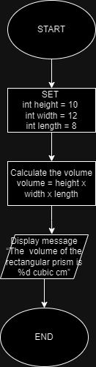

**Problem Statement 2:**

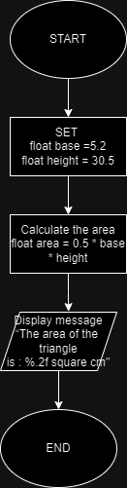

**4.3 Code**

**Problem Statement 1:**

**Problem Statement 2:**

**4.4 Output**

**Problem Statement 1:**

**Problem Statement 2:**

**5.0 Conclusion**

These two programs basically declare the data as int in the first problem statement to calculate the volume and the second problem statement requires the data type in float to get the area with two decimals. These two problems demonstrate the input, process and output shown in the flowchart.